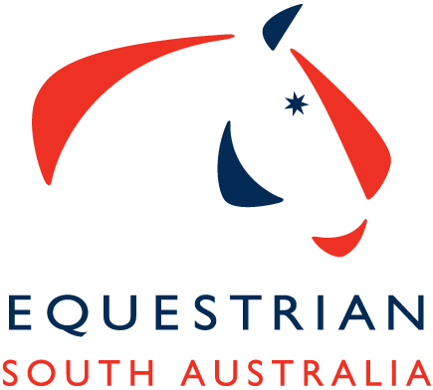
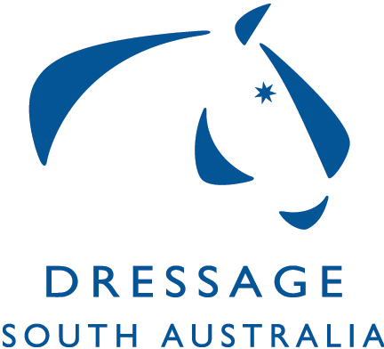
Equestrian South Australia Dressage Awards
FEI Dressage Horse & Rider of the Year
EA Dressage Horse & Rider of the Year
Adult Amateur Owner Rider & Horse of the Year
Dressage Young Rider & Horse of the Year
Dressage Pony & Rider of the Year

The Equestrian South Australia (ESA) Dressage South Australia (DSA) Committee makes an award each year to the most successful Horse/Pony and Rider Combinations.

The awards are announced and presented at The Equestrian South Australia Annual Awards Night held at the end of January or early February each year. The winning combinations are awarded an embroidered rug.

These awards are an aggregate of the below nominated competitions held at South Australian dressage competitions over the course of the year, as well as the Australian Dressage Championships, Australian National Young Rider Championships and the AOR National Championships held interstate. Please refer to the DSA Calendar of events for the nominated events on the ESA Website. https://www.sa.equestrian.org.au/sites/default/files/2020%20Dressage%20Calendar.pdf

The annual awards are open to all ESA competitive members and registered horses that hold a current dressage license. The winner of each division will have the highest aggregate score from the selected competitions held during the year. Results are taken from the nominated competitions official competitive results on the ESA result data base.

Riders are required to nominate for the 2020 annual awards via nominate, entries will open in Mid December 2019 and be advertised on the Dressage facebook page, this will be a rolling intake however points will not be back dated if you enter after you have competed at a nominated event.

There is an administration fee per award for each horse and rider combination that includes GST, $11 for the first horse $8.80 for the second and $5.50 for the third. One rider may enter the same award on multiple horses or may enter different horses to different awards but cannot ride the same horse in multiply awards.

Criteria for the awards listed above
- Riders must be current ESA Members.
- Horses/Ponies must be EA (SA registered) and have a current Dressage Competition Licence/Card.
- Points are awarded individually to each horse/pony and rider combination placing in official tests at the nominated events.
- Riders with more than one horse/pony will accrue separate points for each horse/rider combination in their nominated award category.
- Points only awarded if 60% or over is obtained.
- Participant, Closed Restricted, Closed Unrestricted, Freestyle, tests do not count.
- Pony dressage classes count for points.
- Youth Rider age is from the beginning of the calendar year in which the rider turns 10 years for horses and 8 years for ponies to the end of the calendar year in which the rider turns 21. This is a combined group, based on current EA Rules for Juniors and Young Riders.
- Amateur Owner Rider, in order to qualify as AOR riders must declare that they meet the criteria as set out in the National Dressage Rules 4.6.1. It is the amateur owner rider’s responsibility to make sure they have made it clear on their entries to ride as an AOR and the draw clearly states AOR – this cannot be back dated, if not on draw as AOR a combination cannot accrue points for that specific competition – The onus is upon the rider to make this clear prior to the competition.
- https://www.equestrian.org.au/sites/default/files/2020_EA_National_Dressage_Rules-Clean_Version%20-%20Final_15-1-20.pdf

Results from the following competitions for 2020 will go towards the ESA Annual Awards
- MCDC – Dawn to Dusk 8th February 2020
- SADA 1st March 2020
- SA Dressage Championships / MCDC Autumn Festival 18th & 19th April 2020
- DSA Fundraiser 6th June 2020 Elem-FEI Indoor ~ FEI Points awarded only no EA points awarded
- SFDC 21st June 2020~ Only EA, AOR, Pony & Youth Points Awarded no FEI points awarded
- Australian National Young Rider Championships QSEC, Caboolture, QLD 3rd - 5th July 2020
(Young Rider Points ONLY)
- SVDC 19th July 2020~ FEI Points awarded only no EA points awarded- Indoor Comp
- SVDC 20th September 2020
- Australian Amateur Owner Rider Championships, Boneo Park 12th & 13th September 2020
- MSEDC SA Country Championships 26th & 27th September 2020
- AHDC Spring Festival 10th - 11th October 2020
- National Dressage Championships SIEC 15th & 18th October 2020
- MCDC 28th Nov 2020

Points are allocated as set out below
National Championships
Place | 1st | 2nd | 3rd | 4th | 5th | 6th | 7th | 8th
Points | 8 | 7 | 6 | 5 | 4 | 3 | 2 | 1

SA State Championships
Place | 1st | 2nd | 3rd | 4th | 5th | 6th | 7th | 8th
Points | 7 | 6 | 5 | 4 | 3 | 2 | 2 | 1

Other Nominated Competitions
Place | 1st | 2nd | 3rd | 4th | 5th | 6th
Points | 6 | 5 | 4 | 3 | 2 | 1

