Gear Checking Standard Operating Procedure
A gear checking steward must be present for all horse classes throughout the competition.
All horses must be inspected upon entering the arena before going into the competition ring. If a horse leaves the arena it must be re-inspected upon return. Change of equipment after inspection is not allowed unless a re-inspection occurs.
Gear checking stewards will be provided with a tape measure, copy of the rules and an order of go for the competition.
Equipment of the horse must comply with the Australian Vaulting Rules (listed below).
Australian Vaulting Rules
Horse Equipment Regulations
- Bridle with noseband and smooth snaffle bit, with no more than 2 joints. Rubber bit guards are permitted. If unjointed rubber snaffle is used, the bit must be flexible.
- Minimum diameter of mouthpiece to be 12mm for Horses and 10mm for Ponies. The diameter of the mouthpiece is measured adjacent to the rings or cheeks of the mouthpiece at the widest point.
- Two side reins.
- Auxiliary reins are permitted in Pre Novice Classes and below.
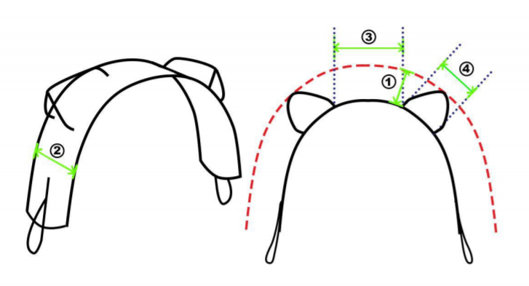
- Vaulting surcingle with under pad and girth. The surcingle has two solid handles (grips) with two loops, one on each side. One short extra strap made of leather may be fixed between the inner edges of the right and left grip.
1. Maximum distance measured from flat face of surcingle to outer point of handles 180mm.
2. Maximum width of weight bearing flat face of surcingle to be no greater than 180mm.
3. Maximum distance between the right hand side and left hand side surcingle handles 240mm.
4. Maximum distance between the centre of the top and bottom fixing points on surcingle handles 280mm. Note --- these are the maximum dimensions, smaller dimensions are acceptable and a tolerance of 20mm will be accepted.

- Lunge rein must be attached to the inner ring of the bit (not over the head or to the outer ring of the bit) or at the lunge cavesson.
- Bandages and/or brushing/overreach boots are optional.
- Ear hoods and plugs are allowed. Ear hoods must not be attached to the noseband.
- Back pad is mandatory and must be made out of a materials which conforms itself to the Horse's back and reduces the impact of external forces (by the Vaulters).One gel pad is allowed in addition to the back pad.
- The back pad, which may be checked by the Gear Steward and/or a Judge at any time on the Horse must have the following dimensions: non-compliance will result in elimination from the competition
  - Max. 80 cm from the back edge of the surcingle to the back
  - Max. 30 cm from the front edge of the surcingle to the neck
  - Max. 90 cm from side to side the lowest point to the lowest point
  - If checked on the Horse, the allowed tolerance may not exceed 3cm, i.e. 93 cm
  - Max. 4.0 cm thick including cover
  - Max. total length 1.10 m, with no more than 30 cm in front of the surcingle
- Lunge cavessons are allowed with or without bit.
- The surcingle and the back pad may be changed between tests.
- A gear steward is authorised to check the bit of any Horse immediately after it leaves the arena and any discrepancy will entail immediate elimination.
The equipment of the Horse in the warm-up arena will be as above with the following additions:
- Auxiliary reins are allowed.
- A Double bridle is allowed when riding.

