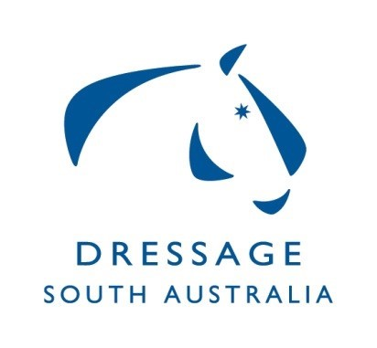
Dressage SA Committee
Summary of Minutes for Meeting on 07/10/19,
at ESA Office Unit 2, 10 Cameron Rd Mt Barker

All positions declared open – nominations put forward and accepted.

Discussion regarding DSA sponsoring National Dressage Championships.

EADC annual meeting to be held on 16th Nov 2019 Sydney Airport Holiday Inn. Chair to attend.

Information from National Safety Officer re privacy issues on concussion discussed.

DSA to follow up with ESA regarding regional grant funds.

DSA to follow up cost of engraving of trophies for State Championships from previous year.

Brett Parbery Squad clinic & Master Class (MC) discussion and organisation of event.

Vanessa Way clinic – Approved by ESA Board.

Clubs Meeting to be organised.

2019 AOR Pryde’s EasiFeed leader board discussion.

2020 HOTY dates to be updated with AOR, FEI, EA. TBC dates for AOR nationals and Yth Nationals.

2019 GIll Rolton Youth Development Scholarship Weekend venue is booked, coach will be Brett Parbery. Discussion surrounding organisation and lessons times.

Regional Clinic/Dressage Training Camp to be run at MCDC in May discussed.

High Performance Off Horse Session meeting with EVT/SJ organised. HPP grant from ESA National – Sessions to include Roger Rasheed & Jacqui Sanderland.

Correspondence - 2 Items ratified

