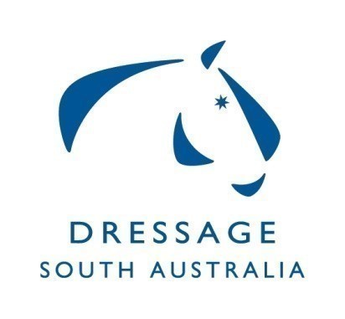
Dressage SA Committee
Summary of Minutes for Meeting on 16/03/20
at ESA Office Unit 2, 10 Cameron Rd Mt Barker

Winter Carnival in June discussed, Covid-19 protocols may impact the event progressing.
May 16th 17th regional dressage training camp will be dependent on Covid-19 protocols.
National Dressage Meeting 30/10/20 - 01/11/20. Dates to be confirmed closer to the date- DSA representative to attend chair or vice.
HOTY - 2021 to be discussed at next meeting.
Vanessa Way clinic – to be rescheduled due to Covid 19.
Vanessa Way Masterclass – has been closed on Nominate. Refunds to be processed via nominate.

Off Horse High Performance sessions – Rules and Safety 30th March 2020 – Merideth Chapman and Dr Alison Aldcock from EA National – Cancelled due to Covid 19.

Calendar – Need to update dates Yth Nats 3rd - 5th July QLD, AOR Nats 12th 13th Boneo and changes to AHDC Sept 2020.

Clubs – Meeting for 4th May 2020 and dependent on Covid-19 protocols.

Update of current and past winners of DSA Awards for this and future Moving Forward contributions.

State Championships – MCDC have implemented a watch and act approach regarding all future competitions in response to Covid-19 protocols. Discussion regarding insurance implications that need to be considered.

Correspondence - 3 Items ratified.

