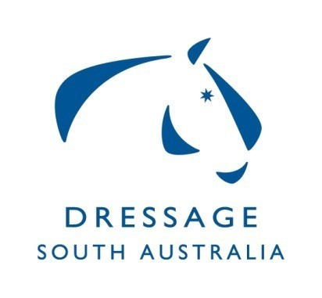
Dressage SA Committee
Summary of Minutes for Meeting on 18/12/19,
at ESA Office Unit 2, 10 Cameron Rd Mt Barker

HOTY awards rug costs confirmed from ESA office.
Confirmation from MCDC to share Virginia Creed and run a Regional/Training Dressage camp.
Discussion around condensing the Squads.
Feedback from the Brett Parbery Squad Clinic and Masterclass was all positive. Financials ratified.
Vanessa Way clinic still waiting on final confirmation of costs and venue. VW has confirmed happy to present a masterclass.
Discussion around the complaints process for Clubs regarding bad rider behaviour.
Gill Rolton Youth Development Scholarship weekend discussed.

Discussion regarding Regional/Dressage Training camp in May.
Confirmation from ESA board that DJSC will come back under the DSA.
State Dressage Championships secured 3 interstate Judges and requires 1 more. Discussion around possible options.
ESA Board confirmed that all DC’s will be getting individual bank accounts with read only access for chair and treasurer.
DSA Chair provided update on EADC meeting on 16/11/19 - most notable was the discussion around AOR rules and changes.
Correspondence - 3 items ratified.

