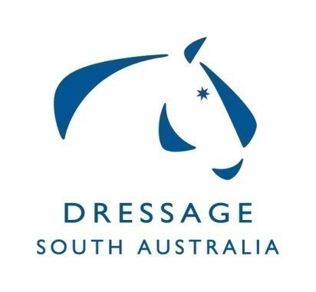
Dressage SA Committee
Summary of Minutes for Meeting on 20/07/20
at ESA Office Unit 2, 10 Cameron Rd Mt Barker

Gillian Rolton Youth Scholarship 2019 follow up grant proposal, Board requires underspent money to be used by September 2020. 24 applicants from the 2019 GR-YS will be invited.
Squad applications closed 06.07.2020 and all applications forwarded to Selectors.14 eligible applicants accepted for the Squad. Committee will invite Squad applications at the end of December 2020 to fill any vacancies.
Clubs meeting set for 31.08.2020 - calendar to be updated – HOTY Criteria presented – judges levies update to be presented.

Dressage Judges Sub Committee reported the grant underspend proposal from the DJSC has been accepted and 2 Judges workshops will be held in regional areas.
State based competition 'Trophy Challenge' will run under an amended format without the need for interstate judges (swabbing will apply). State Trophy's will be awarded and contribute to HOTY points.
2021 SA State Dressage Championship dates to be forwarded to the Board and provided to Clubs. Committee identified 26th to 28th March 2021 did not clash with other major competitions including DJWTS.
Clubs must submit scores for HOTY within the time prescribed.

Pixio has been purchased from ESA operations and will be shared by all disciplines under a booking system through the office.

Discipline Committee Review: Vision Statement considered by the Committee.
Committee discussed and agreed on the process for effective management of all email correspondence.
31 Items Ratified

