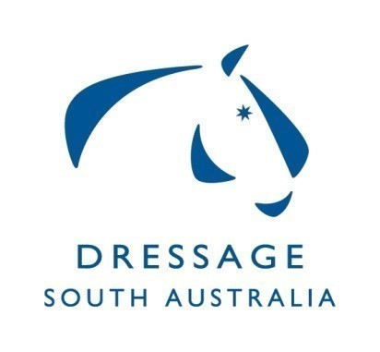
Dressage SA Committee
Summary of Minutes for Meeting on 24/02/20
at ESA Office Unit 2, 10 Cameron Rd Mt Barker

Out of session items: New member co-opted to the DSA. Club requesting to run one judge. Grade imported horse.

Board Meeting with DSA - DSA discussed the request to use income from Dressage cards – pending FARMC meeting for a response.
Nomination of treasurer and secretary completed.
DSA to assist DJSC in following up outstanding Judges levies.
Discussion around riders attending official competitions without competition licenses and the implications including fines.
Squad criteria updated and discussed. To be uploaded on website and set up on Nominate.
Vanessa Way clinic – All going well. Lessons filling.

Vanessa Way Masterclass to be held at Mclaren Park – is now a Judges workshop – tickets are open on Nominate.

Off Horse High Performance sessions – Roger Rasheed 17th Feb was well received. Next one is Rules and Safety 30th March 2020.

Calendar – Need to update dates Yth Nats 3rd - 5th July QLD, AOR Nats 12th 13th Boneo Park.

Dressage training camp 16th/17th May 2020 – running encourage comp on day 2, volunteers from Squad to be asked to assist with judging.

Dressage Judges Sub Committee report submitted – calendar of judge education sessions can be found online. The current three-year cycle for Judge re-accreditation will be completed at the end of 2020.
The JSC is seeking new committee members. Currently a group of 4 but this is not sufficient.
State Championships – 5 interstate judges secured. Swabbing fee to be added to entries.
Winter Carnival discussed.

Correspondence - 2 items ratified

