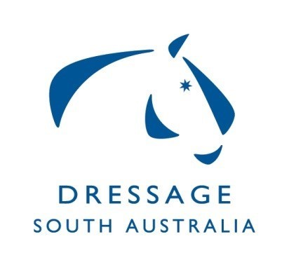
Dressage SA Committee
Summary of Minutes for Meeting on 04/11/19,
at ESA Office Unit 2, 10 Cameron Rd Mt Barker

Confirmation received from Gow Gates that they are aware of the use of CRT5 and that as long as the process ESA has put in place is adhered to, volunteers are covered. This information to be forwarded to Clubs for clarity.
Confirmation received regarding areas classed as regional for the Regional Grant.
Trophy Engraving has been organised and trophies will be engraved before the upcoming state champs with the previous winners.
ESA awards night rugs will be managed and ordered by the ESA office, DSA to fund.
High Performance Off Horse Session meeting with EVT/SJ went well and proposal has been submitted to EA National for approval. Should be approved before Brett Parbery MC.
HOTY 2020 discussed, a small fee will be applicable to cover the rug costs, information to be distributed to the dressage community. Dates to be confirmed once Clubs calendar is completed.
Squad 2020 – Discussion regarding condensing the Squad.
MCDC has Virginia Creed booked for Dawn and Dusk 9th 10th Feb – potential for squad training clinic to be included.
Brett Parbery Masterclass tickets selling well. Further discussion around organisation on the day, information to be communicated to the dressage community. Masterclass rider applications have been forwarded to Brett Parbery to select riders.
Vanessa Way is booked for the 4th 5th April 2020 – air fare will be split with Victorian Clinic – Vanessa Way is considering the option of presenting a masterclass. Discussion around organization.
Clubs meeting booked for 19/11/19 - Agenda sent.
2019 Gill Rolton Youth Development Scholarship Show horse & Carraige Driving have agreed to a combined weekend in January 2020. Brett Parbery is the coach and is booked.
Regional/Dressage training camp all levels of riders 16th 17th May at MCDC – discussion around costs.
Dressage Judges Sub Committee DSA to confirm with ESA Board if it will remain the responsibility of the Dressage Committee now that there is a constitutional Dressage Committee
Discussion regarding State Championships sponsorship.
Correspondence - 4 items ratified.

