Level 3
Compulsory Section
Pre-Novice Compulsories at Canter
- Vault on
- Basic Seat
- ½ Flag
- Plank
- Inside Seat
- Outside Seat
- Kneel
- Dismount to inside
*Vaulters must show all compulsories in the correct order and all exercises must be held for 4 strides
*Mount at walk or an assisted mount will be accepted as a pass
Freestyle Section – Walk
- 6 static moves (held for 3 strides)
- 4 dynamic moves
Theory Section
- 6 oral questions to be taken from the Australian National Vaulting Rules (Question bank provided)
Horsemanship Section
- Show how to tack up the horse for a training session
- Name the parts of the surcingle
- Explain how to care for the equipment
- Name 3 points of a horse from a diagram

Accepted Questions & Answers
Theory Section (Choose 6)
- Name the two parts that Pre-Novice individual vaulting consists of.
Compulsory and Freestyle
- How long must an individual freestyle go for?
One minute
- How many strides must you hold a static freestyle exercise at canter?
Three strides
- What are the components in the scoring of a freestyle?
Horse Score, Technique Score, and Artistic Score
- What is the maximum score you can get for degree of difficulty?
10
- How many vaulters may be on the horse at any one time in squad competition?
Three vaulters
- What is an ‘R’ deduction and how many points are deducted?
Retaking the grips, 2-point deduction
- Name the three types of competition.
Squad, individual, and pas de deux
- In what gait are the Pre-Novice compulsories performed?
Canter
- In what gait are the Preliminary and Pre-Novice freestyles performed?
Walk
- If your movement was “sufficient”, what would it have scored?
5 points
- If your movement was “good”, what would it have scored?
8 points
- Under what bodies does vaulting run?
EA and FEI
Horsemanship Section
- Name the parts of the surcingle
Grips or handles/girth/stirrup/side rein attachment points
- Explain how to care for the equipment
Keep clean, free from dust and dirt. Clean leather gently with water and leather soap. Store in dry environment away from direct sunlight
- Name 3 points of a horse from a diagram

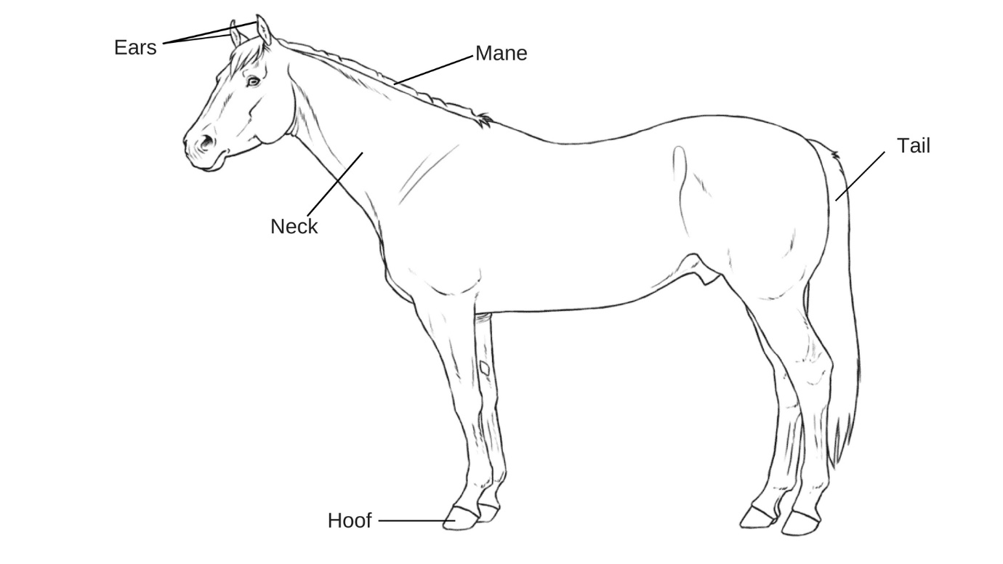

Level 3 Assessment Form Name: ……………………………………………………

Compulsory Section
Pass: Indicate with a P in the relevant box (P)
Fail: Indicate with a F in the relevant box (F)
Vault on | Basic Seat | ½ Flag | Plank | Inside Seat | Outside Seat | Kneel | Dismount

Signed Off
Name: ………………………………………………… Date: ……./………/……….

Freestyle Section
Pass: Indicate with a P in the relevant box (P)
Fail: Indicate with a F in the relevant box (F)
Static
Dynamic

Signed Off
Name: ………………………………………………… Date: ……./………/……….

Theory Section
Pass: Indicate with a P in the relevant box (P)
Fail: Indicate with a F in the relevant box (F)
Q1 | Q2 | Q3 | Q4 | Q5 | Q6

Signed Off
Name: ………………………………………………… Date: ……./………/……….
Horsemanship Section
Pass: Indicate with a P in the relevant box (P)
Fail: Indicate with a F in the relevant box (F)
Name the parts of the roller | Explain how to care for the equipment | Name 3 points of a horse from a diagram
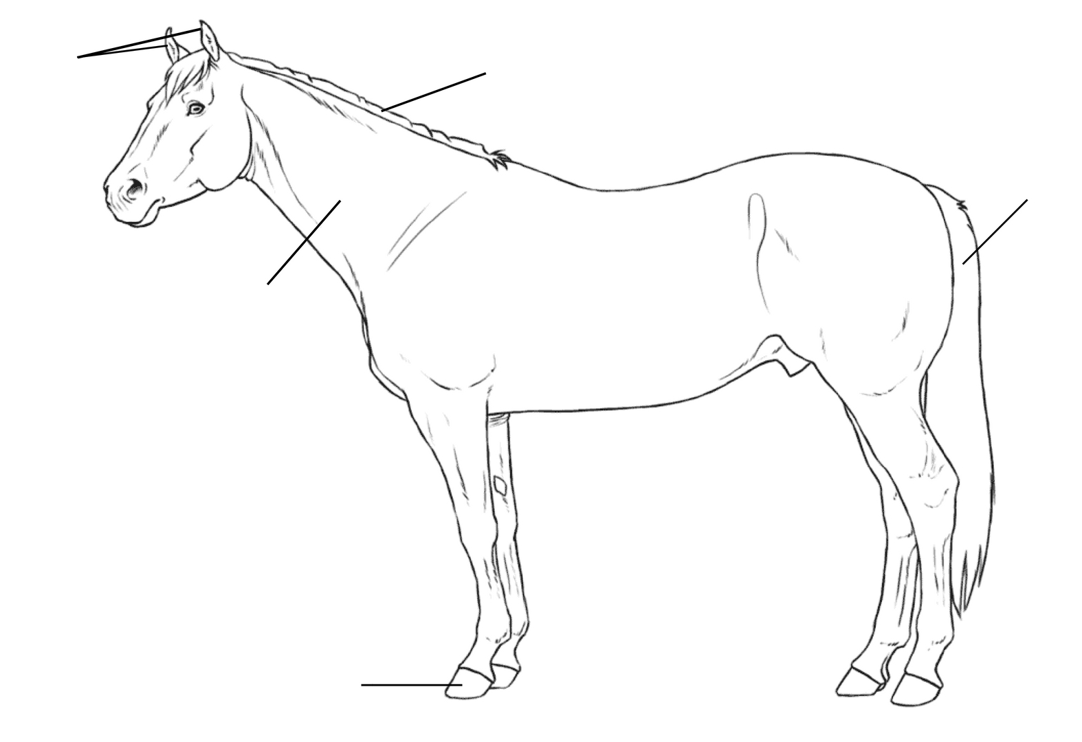

Signed Off
Name: ………………………………………………… Date: ……./………/……….

