Level 4
Compulsory Section
Pre-Novice Compulsories at Canter
- Vault on
- Basic Seat
- ½ Flag
- Plank
- Inside Seat
- Outside Seat
- Kneel
- Dismount to inside
*Vaulters must show all exercises at canter in the correct order
*Must score a final compulsory score of 5.0 or above
*Mount at walk or an assisted mount will be accepted as a pass as long as the overall score is 5.0 or above

Freestyle Section – Walk
- 6 static moves (held for 3 strides)
- 4 dynamic moves
- All moves must be completed in 1 minute

Theory Section
- 10 oral questions to be taken from the Australian National Vaulting Rules (Question bank provided)

Horsemanship Section
- Show how to put a bridle on a horse
- Explain how to clean a stable
- Know parts of a bridle
- Know parts of the horse

Accepted Questions & Answers
Theory Section (Choose 10)
- How many strides must freestyle exercises be held for?
Three strides
- Must every vaulter in a squad show all the compulsory exercises
Yes
- Name 3 pieces of equipment the vaulting horse wears in competition.
Roller/surcingle, side reins, lunge rein, work boots/bandages, bridle, back pad, roller pad
- What is the deduction if a vaulter doesn’t box before a flag or stand?
One point (K)
- Name one static and one dynamic exercise.
Left to assessor’s discretion
- When does the time for a compulsory test start in Squad?
When the first vaulter touches the handles
- What score do you get if you retake the grips twice in stand?
Zero
- How many vaulters may be on the horse at any one time in Squad competition?
Three vaulters
- Are you allowed to lunge in a competition if you are 15 years of age?
No, you must be 16 for EA, 18 for FEI
- How many beats does the canter have?
Three beats
- What is the penalty for wearing jewellery in competition?
Deduction of 1.0 point from the Artistic Score
- What is the most important thing in vaulting?
Your horse
Horsemanship Section
- Show how to put a bridle on the horse
Assessor’s discretion
- Explain how to clean a stable
Assessor’s discretion
- Know parts of a bridle
Browband, bit, cheek piece, nose band, throat latch, flash
- Know parts of the horse
Wither, head, poll, elbow, shoulder, flank, hock, rump
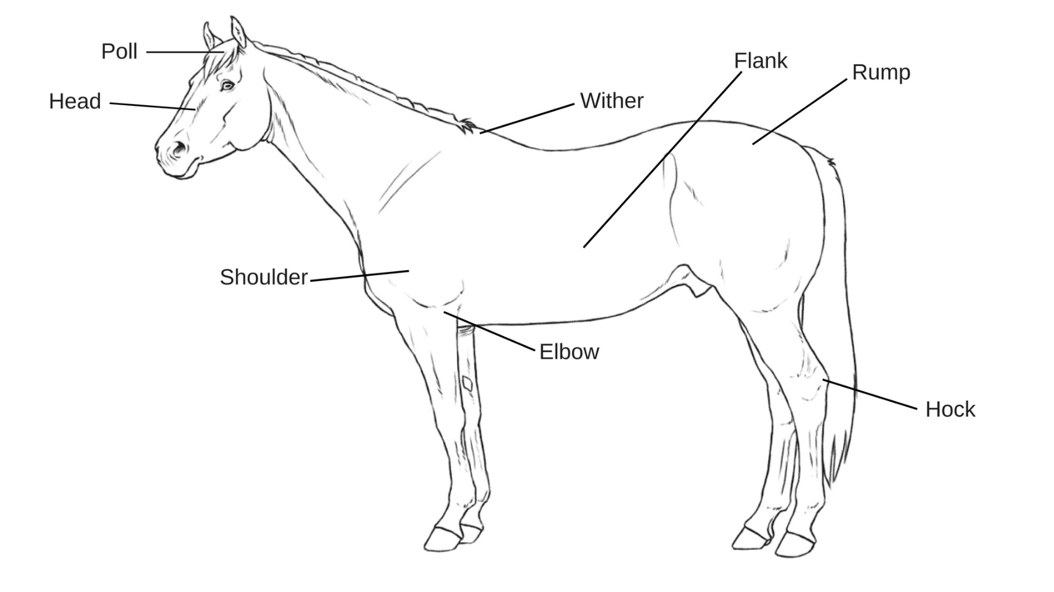

Level 4 Assessment Form Name: ……………………………………………………

Compulsory Section
Write score in appropriate box
Vault on | Basic Seat | ½ Flag | Plank | Inside Seat | Outside Seat | Kneel | Dismount
Average

Signed Off
Name: ………………………………………………… Date: ……./………/……….

Freestyle Section
Pass: Indicate with a P in the relevant box (P)
Fail: Indicate with a F in the relevant box (F)
Static
Dynamic

Signed Off
Name: ………………………………………………… Date: ……./………/……….

Theory Section
Pass: Indicate with a P in the relevant box (P)
Fail: Indicate with a F in the relevant box (F)
Q1 | Q2 | Q3 | Q4 | Q5 | Q6 | Q7 | Q8 | Q9 | Q10

Signed Off
Name: ………………………………………………… Date: ……./………/……….

Horsemanship Section
Pass: Indicate with a P in the relevant box (P)
Fail: Indicate with a F in the relevant box (F)
Show how to put on a bridle | Explain how to clean a stable | Know parts of a bridle | Know parts of a horse
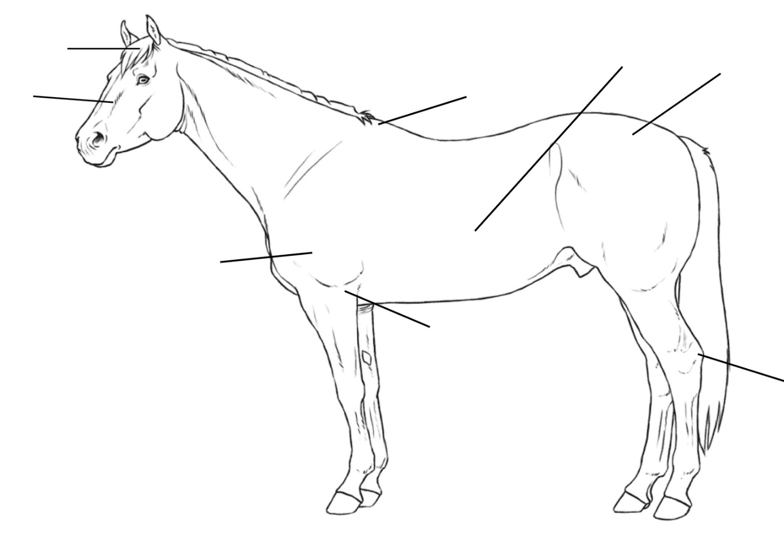

Signed Off
Name: ………………………………………………… Date: ……./………/……….

