Level Bronze
Compulsory Section
Intermediate Compulsories at Canter
- Vault On
- Basic Seat
- Flag
- Stand
- Swing Forward with legs closed
- Half Mill
- Swing Backward with legs open
- Dismount to Inside

Freestyle Section - Canter
- 1 minute freestyle at canter
- No degree of difficulty

*Combined compulsory and freestyle must score 5.0 or above to pass

Theory Section
Complete the following FEI Campus courses:
https://campus.fei.org/
Equine Behaviour - https://campus.fei.org/course/info.php?id=14
Basic Management & Care - https://campus.fei.org/course/info.php?id=50

Certificates must be provided to prove completion.

Horsemanship
- Show a competition entry, halt and salute with a horse
- Lunge a horse at walk and trot without a vaulter

Level Bronze Assessment Form

Name: ……………………………………………..

Compulsory Section
Vault On | Basic Seat | Flag | Stand | Forward Swing | Half Mill | Backward Swing | Dismount
Average

Freestyle Section – Canter
Horse Score | Artistic Score | Exercise Score | Total Score

Combined Compulsory & Freestyle

Signed Off
Name: ………………………………………………… Date: ……./………/……….

Theory Section
Equine Behaviour Completed [ ]
Basic Management & Care Completed [ ]

Signed Off
Name: ………………………………………………… Date: ……./………/……….

Horsemanship Section
- Show a competition entry, halt and salute with a horse
- Lunge a horse at walk and trot without a vaulter

Pass: Indicate with a P in the relevant box (P)
Fail: Indicate with a F in the relevant box (F)
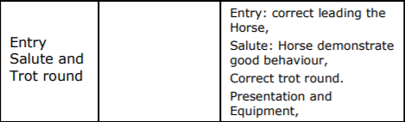
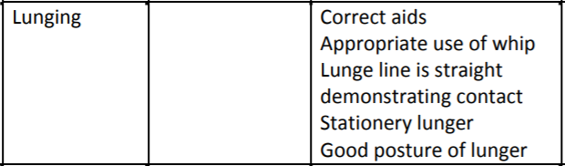

Signed Off
Name: ………………………………………………… Date: ……./………/……….

