Level Gold
Compulsory Section
Open Compulsories at Canter
- Vault On
- Flag
- Mill
- Scissors Forward
- Scissors Backward
- Stand
- 1st part Flank
- 2nd part Flank

Freestyle Section - Canter
- 1 minute freestyle at canter
- With degree of difficulty

*Combined compulsory and freestyle must score 6.0 or above

Theory Section
Complete the following FEI Campus courses:
https://campus.fei.org/
The Musculoskeletal System Basics - https://campus.fei.org/course/info.php?id=73
How Horses Learn - https://campus.fei.org/course/info.php?id=56

Certificates must be provided to prove completion.

Horsemanship Section
- Prepare a horse for trot up
- Demonstrate a trot up
- Lunge a horse at walk, trot, and canter without a vaulter

Level Gold Assessment Form Name: ………………………………………….

Compulsory Section
Vault On | Flag | Mill | Forward Scissors | Backward Scissors | Stand | 1st Flank | 2nd Flank
Average

Freestyle Section – Canter
Horse Score | Artistic Score | Exercise Score | Technique Score | Average

Combined Compulsory & Freestyle

Signed Off
Name: ………………………………………………… Date: ……./………/……….

Theory Section
The Musculoskeletal System Basics Complete [ ]
How Horses Learn Complete [ ]

Signed Off
Name: ………………………………………………… Date: ……./………/……….

Horsemanship Section
Pass: Indicate with a P in the relevant box (P)
Fail: Indicate with a F in the relevant box (F)
Horse Preparation | Trot Up

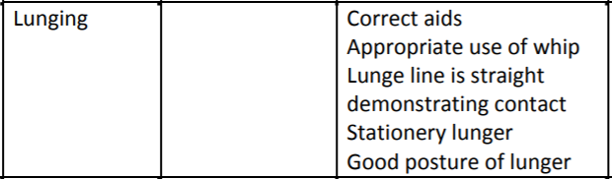

Signed Off
Name: ………………………………………………… Date: ……./………/……….

