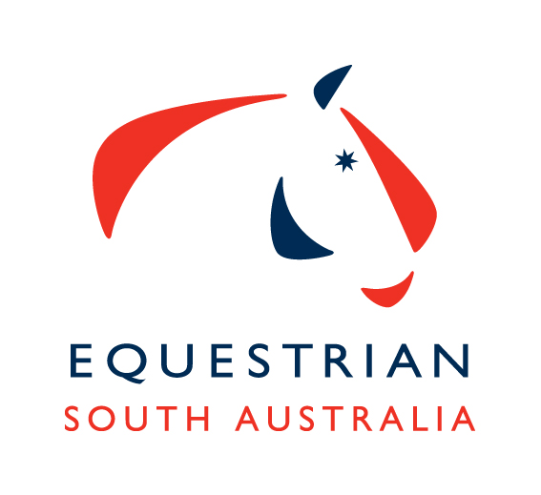
ESA Merchandise Order Form

Name: ________________________________________________
Address: (if posting) ______________________________________________________
Mobile: _____________________
Please note – Check your sizing carefully as there are no exchanges or refunds.
Item | Cost | Size | Number of Items | Total
Bathurst Jacket  Unisex - XS,S,M,L XL,2XL,3XL | $85
Hoodie  Unisex - S,M,L XL,2XL,3XL  Ladies – 4,6,8,10,12,14,16 | $57
Polo Shirt – Short Sleeve  Kids – 4,6,8,10,12,14  Fitted Ladies - S,M,L,XL,2XL,3XL  Unisex – XS,S,M,L,XL,2XL,3XL,4XL | $45
Polo Shirt – Long Sleeve  Kids – 4,6,8,10,12,14  Fitted Ladies - S,M,L,XL,2XL,3XL  Unisex – XS,S,M,L,XL,2XL,3XL,4XL | $50
Cap | $19 | One Size Only
Beanie | $19 | One Size Only
Embroidery discipline logo or text to front right of Jacket or Hoodie | $9 | List text or logo required in this box.
Additional text to back, lower section of Jacket or Hoodie | $9 | List text required in this box.
Tick red box if collecting items from the ESA Office MT BARKER.
Postage Cost – Contact the office as postage will vary depending
on amount purchased. ESA Office : 8391 0488 Postage
Grand Total

To purchase these items via credit card, please fill out the details below and email to the ESA Office admin@equestriansa.com.au or contact the office on 8391 0488 to arrange payment over the phone.

Visa Mastercard

Card Number __ __ __ __ __ __ __ __ __ __ __ __ __ __ __ __

Name On Card ………………………………………………………… CCV …………… Exp Date ……………..…

Signature_________________________

